Shamus, Peter, and Adam: The argument in this paper is carved out from my next book project. Omar Lizardo will join me as a co-author for the next draft. He hasn’t contributed his text & analysis, but he will explore age & cohort effects in relationship to elite omnivorous tastes. At the risk of getting you excited, I’ll add Omar’s preliminary analysis after the bibliography.

We may re-organize the argument in light of his findings, to better resemble his recent piece comparing Spain and Portugal. It might look like this:

- General theoretical setup (e.g. establishing the lack of studies that link production of culture/consumption of culture, macro/micro, etc.)
- Quantitative demonstration that something interesting is going on (showing the higher preponderance of arts/folk festival consumption the in the 1930/1950 generation).
- Analytical historical narrative making the case that all sorts of organizational/state activity to establish a field of cultural production/legitimation of folk arts in the U.S. generated a historical legacy of interest in this domain in this generation.
- discussion/conclusion/implications/contributions.

A slight variant of this setup would begin with (b1) some historical analysis to actually setup the quantitative findings then (c) present the cohort models, and then (b2) shed further light on the generational specificity of the cohort effects with some more historical narrative.

The current draft is written as a “mirror” of Paul DiMaggio’s famous piece on Boston. Given all that, comments on my use of the historical data and argument may be of greatest value to me.
Thanks!
Jenn

Organizational and Institutional Foundations of Omnivorousness in the United States: The W.P.A. and the Folk Festival

Jennifer C. Lena
Teachers College, Columbia University
Draft: Please do not reproduce, distribute or cite without permission

Word Count: 8,484

1. Introduction
An extraordinary re-organization of culture occurred at the turn of the twentieth century: the invention of a boundary between “highbrow” and “lowbrow” arts (DiMaggio 1982). The recent broadening of cultural tastes (among segments of the U.S. population) arguably augurs a second transformation and a new boundary of distinction, between narrow cultural “univores” and “omnivores” (Peterson and Simkus 1993). During both historical shifts, arts presenters provided programming to reflect shifting elite tastes, and to attract mass audiences and support budgets. To the best of my knowledge, scholars have yet to connect changes in 20th century United States arts organizations, and institutional practices within them, to their influence on the appearance of elite omnivores in surveys from the 1990s. In this paper, I trace one historical sightline, from the activities of New Deal arts agencies, through benchmark arts organizations in the post-war years, to contemporary elites.

2. Major Transformations in Art Organizations and Institutions in the U.S.

In an influential article, Paul DiMaggio (1982) attributes the emergence of a distinction between high and popular culture in the U.S. to organizational and institutional transformations that took place in 19th century Boston. High culture, a strongly classified, consensually defined body of art, distinct from popular fare, was the consequence of work by urban elites to create organizations that isolated and sacralized it. It failed to develop in Boston prior to 1870 partially because no existing organizations were equipped to define and sustain the institution of fine or “high” art. DiMaggio argues that the non-profit corporation made the sacralization of art possible because the form was a familiar tool to elites, insulated from market processes and from state intervention, provided the stability for these changes to take place, and their charters stipulated diffuse enough goals to accommodate conflicting purposes and changing ends.
These organizational changes were accompanied by efforts to institutionalize high culture. DiMaggio identifies three key activities that occupied Brahmin cultural capitalists: (1) entrepreneurship, manifest in the adaptation of an existing organizational form to a new purpose; (2) the classification of works as art or entertainment; and, (3) framing, or the creation of a new relationship between works of art and audiences. He characterizes their challenge: “Boston’s cultural capitalists would have to find a form able to achieve all these aims: a single organizational base for each art form; institutions that could claim to serve the community, even as they defined the community to include only the elite and upper-middle classes; and enough social distance between art and audience, between performer and public, to permit the mystification necessary to define a body of artistic work as sacred” (1982: 38).
DiMaggio’s analysis of the emergence of high culture in America emphasizes the mutually constitutive nature of organizational activities and cultural institutions. He is not alone in demonstrating that museums and other benchmark arts organizations (e.g., opera houses, ballet companies and symphony orchestras) play a key role in constructing and reproducing the boundary between consecrated and illegitimate arts (Zolberg 1981; DiMaggio 1982; Alexander 1996a). We know that changes in tastes are often accompanied by changes in organizational practices and institutional elements (inter alia Hirsch 1972); as DiMaggio (2009) later argued: “Just as financial currency lacks value without a state and a banking system to guarantee it, so cultural capital cannot establish or retain its value in the absence of significant institutional effort.” In this article I inquire: if elite tastes have undergone a transformation in the 20th century, what organizational and institutional changes have taken place to make that shift possible?
The transformation in elite tastes that occurred in the wake of World War II is beyond dispute; the tastes of elite Americans expanded to include popular works and genres in addition to the fine arts. In a landmark article, Peterson and Simkus (1993) used cross-sectional surveys of Americans’ musical tastes to demonstrate that “highbrow snobbery”—elites’ exclusive taste for highbrow arts—had been replaced by “highbrow omnivorousness.” While a small minority of American elites clung to exclusive tastes for highbrow culture (e.g., opera, classical music), most enjoyed a range of popular entertainment including music, craft fairs, and blockbuster films. The Survey of Public Participation in the Arts (SPPA), on which the study was based, asks respondents to tick off all the musical styles (e.g., classical, rock, classic rock) they enjoy from a list provided to them. Peterson and Simkus (1993) argued that elites are increasingly omnivorous because younger elites in recent surveys indicated a greater number of styles among their preferences, on average, than elites who completed earlier waves of the survey, or who were older. In a follow-up study, Peterson and Kern (1996: 904) concluded that “snobbish elitism [has been] replaced by cultural relativism.”
A generation of scholars has refined our understanding of omnivorousness. The presence of eclectic tastes among high-status individuals has been discovered in multiple countries including Canada (Fisher and Preece 2003), the United Kingdom (Gripsrud 1989; Blewitt 1993), the Netherlands (van Eijck 2001), France (Donnat 1994; Bellevance et al 2004; Coulangeon 2005), Germany (Schulze 1992), Spain (López-Sintas and Garcia-Alvarez 2002), Austria (Gebesmair 1998) and Australia (Bennett et al 1999; Emmison 2003), and in additional analyses of the United States population (see Peterson 2005 and López-Sintas and Garcia-Alvarez 2005 for a review). These studies document shifting tastes across a range of cultural pursuits, including music (Peterson and Kern 1996; van Eijck 2001; Bennett 2006; Bukodi 2007), reading (Zavisca 2005), art (DiMaggio and Mukhtar 2004; Vander Stichele and Laermans 2006) and most recently, food (Johnston and Baumann 2007) and television (Lizardo and Skiles 2009).
Within the corpus of works examining omnivorousness, a number of disputes have emerged. Although a comprehensive review of these debates is beyond the purview of this article, I wish to briefly note that the most important question (given our focus here) concerns whether elites consuming “middlebrow” and “lowbrow” culture are making discriminatory judgments at the intra-genre level that are being missed in surveys like the SPPA. Although elites and non-elites may both profess a preference for country music, for example, they may be listening to quite different songs or artists within that corpus. Johnson and Baumann’s (2007) research suggests intra-genre distinctions orient the tastes of “foodies,” who discriminate among restaurants and dishes on the basis of their perceived authenticity. In fact, the emerging consensus in both qualitative and quantitative research on the nexus of boundary work is that omnivorous elites are consuming diverse material they can describe as “authentic,” traditional, sincere, and particular (to time and space). Omnivores discriminate within genres and the discourse they use to describe their experiences is characterized by a values orientation toward cultural relativism, social tolerance, and a spirit of “democratic” inclusiveness (Bryson 1996; Johnston and Bauman 2007; van Eijck and Lievens 2008). The discourse and choices made by omnivores like foodies allow them to navigate “a fundamental ideological tension between democracy and distinction” (Johnston and Baumann 2007: 169) through their consumption. Impolitic snobbishness is avoided using a mode of cultural appreciation in which cultivated palettes and the status they confer are “framed as a matter of individual tastes and lifestyles, which are posited as sophisticated, savvy, and cosmopolitan.” This suggests that a full understanding of the omnivorous disposition will require us to parse how elites consume the same culture as non-elites but in qualitatively different fashion. Some research of this kind is taking place (Sonnett 2013), informed by Bourdieu’s approach in Distinction (1987; see also Fligstein and McAdam 2012). The obstacle to research in this area is the resource intensity of research at the intra-genre level.
While others explore new methods of generating data on intra-genre consumption, I seek to exploit the possibilities of historical research to identify organizational and institutional changes that facilitated the emergence of elite omnivores. This investigation puts me into conversation with scholars using field theoretic approaches to explore artistic valorization, or the elevation of vernacular genres into art genres. Studies of artistic valorization document transformations in which works are selected for presentation in benchmark organizations, and the consequent legitimation, or “aestheticization,” of the genres into which those works are classified. Notable studies of artistic valorization have been completed on jazz (Lopes 2002; Peterson 2005), rap (Lena and Pachucki 2013), film (Baumann 2001), and cuisine (Ferguson 1998, 2004; Johnston and Baumann 2007).
These studies reveal that artistic valorization is promoted by so-called cultural capitalists, advantaged individuals who possess varied forms of capital that give them the power to re-define artistic classification systems and to situate their tastes in privileged positions (Bourdieu 1987, 1993, 1996). When structural transformations threaten the exclusivity of elite tastes, they simply use their familiarity with, and training in, artistic classification systems to appropriate new works into those systems, a phenomenon discovered in a range of empirical studies (Bernstein 1977; DiMaggio 1987; López-Sintas and Katz-Gerro 2005: 301; Lizardo and Skiles 2012).
In this paper, I explore the artistic valorization of “folk culture” by cultural capitalists in New Deal arts agencies. I examine the consequences of organizational support for folk culture provided by federal, state, and local governments in the New Deal era and how this support then promoted an institutional shift in the treatment of folk culture. In revealing the process by which folk became art, we are able to illuminate some of the organizational and institutional transformations that contributed to the rise of the contemporary American elite omnivore.

3. The New Deal and the Artistic Valorization of Folk Culture in America

The New Deal Art Projects were a phenomenon in our time. Although they are now history, every impartial observer recognizes their supreme importance for the development of American art (Greengard et al 1986: 48).

The activities of the New Deal era arts agencies softened elites to the expansion of the American arts to include forms of what is often called “vernacular” or “folk” culture. The presentation of these works in benchmark arts organizations, and their continuing presence within permanent collections and in the performance canon, ensure recent cohorts of elites treat (some) “lowbrow” cultural forms as legitimate carriers of cultural capital. In this exploratory work, I examine the practices of New Deal arts agencies and their impact on the rise of elite omnivores in the later 20th century. In this section, I provide a summary of the activities of these agencies, and their impacts on benchmark arts organizations and the elites that supported them.
Facing massive unemployment and poverty, President Franklin Delano Roosevelt established federal agencies charged with employing out-of-work artists and with achieving a “picture of democratic justice and spiritual beauty” (Biddle 1939: 267-8, quoted in Mathews 1975). This phrase comes from the memoir of lawyer-turned-artist George Biddle, prep school friend of Roosevelt, and the man credited with suggesting an artist’s work relief program as part of a more comprehensive plan to provide citizen’s assistance in the wake of the Great Depression. Biddle pressed Roosevelt to envision an American dream that involved not just economic and social justice, but also cultural richness and diversity: “Art for the Millions.”
State-level support for indigent artists began as early as 1931, but the first Federal, non-relief project for artists, the Public Works of Art Project (PWAP), was initiated in 1933. This program, with the Treasury Relief Art Project (TRAP, 1935-9), awarded commissions to artists for the production of paintings, sculptures, and murals for display in federal buildings across the nation. A more comprehensive work relief program began in October 1935, and was known as the Works Progress Administration (WPA). Under the WPA, the four programs referred to as “Federal Project Number One” provided subsidies for the production of visual art, music, theater, and literature.
Artists employed under Federal One produced a great variety of art works, including paintings, graphics, motion pictures, murals, photographs, posters, sculptures, and plates for the Index of American Design. Still others taught art and art appreciation; mounted exhibitions, tours, and lectures; built frames and dioramas; and sketched maps. Some creative workers even developed color standards and tested paint in cooperation with the Bureau of Standards. At it’s peak, the WPA employed approximately 5,000 American artists. The output of creative material is astonishing: from 1935 to the closing of the final iteration of this agency in June 1943, artists created 2,566 murals, 17,744 sculptures, 108,099 paintings, 250,000 prints from 11,285 images, 2 million posters from 35,000 designs, and more than 22,000 design plates (O’Connor 1969: 28-9; Greengard et al 1986: 58-60). Estimates of the total cost of the WPA hover around $35 million.
New Deal elites like Harry Hopkins, who was appointed in 1933 to direct monies for actors and musicians, endorsed the vision of a cultural democracy taken up by Biddle and Roosevelt. Hopkins pushed theater directors to depict the deplorable conditions in tenements in the hope that they might encourage a landslide of support for the funding and construction of decent housing for American citizens. The Theater Division commissioned the adaption of non-theatrical material like pageants, dance dramas, and living newspapers in order to dramatize the full range of American life. Playwright Percy MacKaye called for a “Drama for Democracy” and theaters that would be a “civic agency” for “the whole people” (N.A. 1936, “Art: Government Inspiration”).
The Federal Writer’s Project (FWP) employed more than six and a half thousand writers at its peak (in April 1936), and 275 books, over 700 pamphlets, and uncounted leaflets, radio scripts, and transcripts were written during the project’s tenure. The program generated the American Guide Series; several city guides; socio-ethnic studies; expositions on industrial, labor, society, and community issues; poetry; and documents of American and Native American folklore (Gale Cengage Archives Unbound 2014). The Writer’s Project sent reporters into every state to collect what Ben Botkin, director of the Folklore division, called “living lore,” including the testimony of European immigrants and former slaves. They produced 378 books and pamphlets to serve as local, state, and national guides, encouraging Americans to explore the varied lifeways of their nation.
The Historical Section of the Farm Security Administration employed photographers to document “the need for government programs and their benefits,” an effort that yielded over 270,000 pictures (Greengard et al 1986: 58-60). The Farm Security Administration sent writers and photographers into the Dust Bowl states to document the lives of the people there; this work has become famous thanks to James Agee and Walker Evans’s text Let Us Now Praise Famous Men. Musicologist Charles Seeger was encouraged by the Resettlement Administration to foster the unity of communities by encouraging the use of indigenous musical resources. Seeger sought to identify regional, popular and folk music in order to integrate it with academic music into a uniquely American idiomatic expression (Mathews 1975). It is also said that the documentary form finds its roots in the skills and information that filmmakers, photographers, journalists, and artists generated in documenting American life for the WPA.
The Federal Music Project (FMP) is said to have supported 5,000 performances for 3 million people each week, employing roughly 16,000 musicians at its peak (Adams and Goldbard 1995). They staged public performances of over 1,500 compositions by 540 American composers by symphony orchestras, small orchestral ensembles, string quartets, chamber music ensembles, and operatic and light opera concert ensembles; grand opera, light opera, and chamber opera companies; vocal ensembles and vocal soloists; and dance orchestras, bands, and theater orchestras (Federal Works Agency 1947: 64). Other FMP work included the teaching and copying of music and the maintenance of music libraries. An index of American composers and compositions was initiated but left incomplete, but the card files were deposited in the music division of the Library of Congress. Music division director Nikolai Sokoloff reported that his musicians performed works by almost 14,000 American composers in his first year and a half as director, and music transcriptionists recorded folk music of a dizzying variety: white and black spirituals, Spanish songs from the Southwest, Creole ballads from Louisiana, liturgical music from California missions, and bayou songs from the Mississippi delta (Mathews 1975: 336). According to a 1936 brief in Time Magazine, Sokoloff reported that his payroll included 15,639 “players, singers, composers, teachers, librarians, copyists, arrangers, tuners, music-binders” including a 22-piece “gypsy orchestra” in Pittsburg, a Hungarian ensemble in Chicago, and tipica orchestras in San Antonio and Tucson (N.A. 1936, “Music: Relief Melodies,” 1936).
The humble origins of much of this cultural material stood in contrast to the pageantry and even glamor of their display. Operating under the aegis of the federal, state, and local governments, many of these programs presented displays and performances in traditional benchmark arts organizations including the Smithsonian, the National Gallery, the Museum of Modern Art, and the Federal Art Gallery in New York (Greengard et al 1986). The Public Works of Art Project (PWAP) closed with a gigantic exhibition in Washington at which high-ranking government employees were encouraged to take what they liked and to display the art in their offices. President and Mrs. Roosevelt hosted a series of nine concerts of “traditional” musicians at the White House, including one in June 1939 attended by the King and Queen of England, the first reigning British monarchs to visit the U.S. The playbill included the mountain string band the Coon Creek Girls; Marion Anderson, the contralto opera singer; the North Carolina Spiritual Singers; and musicologist Alan Lomax, who performed cowboy songs.
Surveys from the Federal Theater revealed that most audience members were middle class (even in Harlem, and despite a concerted effort to attract low income groups), although those surveys may not have been executed well (Mathews 1975: 330). While the audiences for these performances were large, they were not attracting many non-traditional audience members. Indeed, cultured, liberal, elites were the main beneficiaries. National Art Week did not, as its slogan promised, resolve in “A Work of Art for Every American Home.” Instead, the biggest purchaser was Thomas J. Watson of IBM, who had been appointed by Roosevelt to serve as the National Chairman of Art Week (Mathews 1975: 332).
Harold Lehman, a muralist with the WPA, explains: “artists, formerly ignored by the government, achieved a place in society they never could have reached otherwise—due to active government support for the arts” (Greengard et al 1986: 49). Artist Yasuo Kuniyoshi has argued that the WPA established “the beginnings of great American art” (Kuniyoshi 1940), and that great American art was collected and created by “artists [who] were encouraged to prove the American experience and search for roots in the folk tradition of the people, documenting the values and behavior of a culture in the throes of self-recognition” (Matthews 1975: 334). This new “folk consciousness” importantly included the ethnomusicological forays of Charles Seeger from the music division, John Lomax from the writer’s project (who collected folk music as well), and Cahill’s “Index of American Design” which brought a continuity and distinction to folk art. Add to this the decidedly regionalist preoccupations of Thomas Hart Benton, Grant Wood and John S. Curry. As one historian opined: “the resulting output of Americana was overwhelming” (Mathews 1975: 334).
Congress repeatedly attacked federal arts divisions based on reports of inefficiency and fraud. The Federal Theater project was abolished by Congress in 1939, charged with inefficiency, immorality, and infiltration by Communist agitators (e.g., “it had spent $1,468,365 producing 27 plays, many of them flops”) (N.A. 1939, “Relief: Hot Pan”). The Writer’s Project faced many of the same charges; it’s national director was accused of provoking a sit-down strike in 1937 in which 200 employees on the WPA-Writer’s Project rolls seized and occupied the headquarters in Manhattan. The other programs limped forward into the war years, when they were abandoned.
While some programs, like the Treasury Relief Art Project (TRAP), described as the “Ritz of relief projects for artists,” and directed by “young sociality painter” Olin Dows (given $550,000 to employ no more than 400 artists (N.A. 1936, “Art: Government Inspiration”), were dedicated to helping privileged groups, the New Deal agencies enacted a comprehensive program to produce and support art by ethnic and racial minorities, and the poor. The lasting and, for our purposes, more important, contribution of these agencies was that they provided an opportunity for economic and political elites to consume folk culture as a form of moral engagement with their community and their nation. The WPA created opportunities for the rich to sacralize a new and more diverse group of works as art, and an organizational context within which to do so.

4. The Preservation and Display of New Folk Art

Did the WPA achieve its goal of “Art for the Millions,” and was this work available to post-depression audiences? More research is required in order to recover, locate, and inventory the totality of existing cultural products created under Federal One. However, we do know that multiple local, state, and federal arts organizations ended up in possession of the works created, and many used these acquisitions to form the core of their 20th century collections. The Library of Congress holds 70,000 photographs from the Farm Security Administration (Greengard et al 1986: 58-60) and copies of the FWP’s American Guide Series. The original 22,000 plates from the Index of American Design are housed at the National Gallery of Art in Washington, DC. The U.S. General Services Administration has recovered about 200,000 small works that it keeps as a part of its Fine Arts Collection. At least 290 images of silkscreened posters created by WPA artists for theater productions are available in the National Archives, and 22 play scripts plus set designs, costume designs, and original posters for close to 600 productions are held in George Mason University’s Federal Theater Project Materials Collection. Three WPA symphony orchestras developed into regular community institutions—today, only the Buffalo Philharmonic Orchestra and the Utah State Symphony Orchestra continue to perform for the public (Federal Works Agency 1947: 64).
Von Groschwitz, Supervisor of the Graphic Art Division of the Federal Art Project in New York, claims that 134 color lithographs made by WPA artists were all acquired by museums (including the Metropolitan Museum of Art) and remain in their permanent collections to this day. The Newark Museum also has a great number of WPA-sponsored works in its collection, including Minna Citron’s painting, “Staten Island Ferry.”
In 1977, The Smithsonian Institution Traveling Exhibition Series hosted a display of WPA/FPA graphic art. Prints, architecture designs, and paintings have been shown in A.C.A. and other prestigious galleries in New York, Los Angeles, and Washington, D.C. The Wichita Art Museum (Kansas) and the Leigh Yawkey Woodson Art Museum (Wausau, Wisconsin) are just two of the regional art museums that have hosted WPA shows in the last several decades.

5. The role of cultural capitalists

As eager as most New Deal era arts administrators were eager to endorse Roosevelt’s vision of a cultural democracy, although most of them were raised within the economic, political, and cultural elite (and many were unapologetic elitists). These elites—these “cultural capitalists”—ultimately transformed the institutional practices of benchmark arts organizations such that folk or vernacular works could be included in their collections and repertoires.
Among them was Holger Cahill, Director of the Federal Art Project (FAP) (1935-1943), who, in addition to his duties at the FAP, influenced the curatorial directions of several institutions including the Newark Museum and MoMA, where he served as interim director for a year (1932-1933). He filled in for his frequent collaborator Alfred H. Barr, the first Director at MoMA (1929-1943), and in this post both were concerned with canonizing a vernacular modernism that drew upon the nation’s unique folk traditions. Because of their efforts, MoMA became known for this approach to the modernist project. They were joined by Edith Halpert, an art dealer who co-founded New York City’s first folk art gallery (the American Folk Art Gallery) with Cahill in 1929. All three (Halphert, Cahill, and Barr) had close relationships with Abby Aldrich Rockefeller and worked with her to build her large and influential collection of both modern and folk art (Bacon 2005). After her death in 1948, that collection would became the foundation of the Abby Aldrich Rockefeller Folk Art Museum in Williamsburg, Virginia (Bacon 2005: 30).
In his post as Director of MoMA, Barr was succeeded by another advocate of vernacular modernism and alum of the New Deal arts agencies: formerly Manager of the WPA’s Indian Arts and Crafts Board (IACB), René d'Harnoncourt was an established expert in Mexican and vernacular and modern American art. During his tenure at MoMA (1949-1968), d’Harnoncourt supervised and personally curated numerous exhibitions of folk art from the United States and elsewhere including displays of “African Negro Sculpture” (1952), American woodcuts (1952), toys (1953), “young American printmakers” (1954), “Ancient Arts of the Andes” (1954), animated cartoons, paintings by “amateurs” (1955), graffiti (1956), film posters (1960),”Japanese vernacular graphics” (1961), and a Walker Evans photography show (1962). He also became a close advisor to Nelson A. Rockefeller, Abby Aldrich Rockefeller's son, and supported Nelson’s acquisition of an enormous collection of so-called “primitive art” from Africa, Oceania, and the Americas. It was d'Harnoncourt who encouraged the budding philanthropist to establish his own cultural institution to house his collection. Rockefeller founded the Museum of Primitive Art in 1954 which housed the nation's most extensive collection of art objects from Africa, Oceania, and the Americas until it closed in 1976. In that year, Rockefeller's primitive art collection transferred to the Metropolitan, signaling a shift in the museum’s opinion of these works, and their adoption or recognition of Rockefeller and d'Harnoncourt's veneration of folk art (LaGamma et al 2014).
Equally significant changes were taking place in the performing arts, as cultural capitalists moved benchmark arts organizations toward the goal of preserving and protecting a distinctly American vernacular modernism. The Smithsonian played an important supporting role for New Deal Era agencies, hosting performances and exhibitions throughout the depression years. Administrators there were thus predisposed to support bluegrass promoter Ralph Rinzler when he proposed a Festival of American Folklife in 1965 (Rosenberg 1998). Friendly to the idea, the Smithsonian leadership re-conceptualized Rinzler’s proposal as a series of annual events that would lead up to the 1976 Bicentennial, and hired him to plan the first Festival to be held in 1967.
The Festival is hosted by the Smithsonian Center for Folklife and Cultural Heritage, and is the largest annual cultural event held in the U.S. capital. An estimated one million people attend the festival each year (N.A. 2013, “Smithsonian”). Its programming is a near-mirror of the New Deal art initiatives. The program of song, dance, craft, and workshops is organized to feature nations, states, and regions, and to highlight the vernacular culture of these places.
The catalog for the 1968 Festival of American Folklife draws a clear line of influence between the WPA arts programs and the Festival. Secretary Dillon Ripley’s prologue identifies the New Deal as an era in which America began to recognize and celebrate an “aesthetic tradition of its own” and develop a “culture in which the arts could flourish.” He continues: “We know today that such a culture has been our heritage…. We hope this Festival will serve to bring American people together more fully into touch with their own creative roots, and that from this acquaintance the way may be pointed towards a richer life for some and a more meaningful understanding of the roots of our society” (Ripley 1968: 3).
The Festival is meant to expose Americans to folk culture, and to urge them to view it as art. Former Director of the Center for Folklife and Cultural Heritage, Richard Kurin, stated the festival’s purpose is to display and preserve regional, folk, tribal, and other “non-elite and non-commercial” cultural forms that are “not otherwise likely to be heard in a national setting.” The Festival is designed, in his mind, to legitimate folk cultures using the instrument of a national office and its “standards of authenticity, cultural significance, and excellence” and to convey these cultures’ “value to artists, to home communities, to general audiences and to specialists” thereby providing a “needed counterweight to other forms of delegitimization” (Kurin 1989: 15). To Kurin, the Festival is an instrument that promotes the visibility and legitimacy of hidden or marginal cultures and it performs a socialization function as well: training general and specialist audiences to view these cultures as valuable.
Most experts feel the Festival is inconceivable without the collection, preservation, and display of folk culture during the New Deal Era. Alan Lomax, an influential folk song chronicler, said of that time:

America as a multiple civilization was being recorded, studied, and archived as never before. The White House sponsored and was delighted by the opening up of Washington and the country to further exploration of what kind of place America was, of who Americans were in all their ethnic variety. The Roosevelts and the bright, young, intellectuals of the New Deal and Congress under Roosevelt’s baton put their arms around the whole of American culture ¾ minorities, ethnics, blacks, poor whites, Indians, coal miners, unemployed (Cohen 2005).

Lomax’s remarks were recorded in 1981, as a part of the Smithsonian’s commemoration of the 1939 White House folk concert for King George VI and Queen Elizabeth, at which he performed. He was being interviewed by Ralph Rinzler, a rare moment in which two of the most influential mid-century cultural capitalists for the performing arts discussed the significance of their contributions to the artistic valorization of folk art in America.
The Festival’s impact has been felt in other areas of national artistic life. Its influence is felt in the American Folklife Preservation Act of 1976, the American Folklife Center, the Folk Arts Program at the National Endowment of the Arts, and in programs and festivals held across the country (Kurin 1989: 18-19). It is also said to have influenced UNESCO’s 2003 International Convention on the Safeguarding of the Intangible Cultural Heritage.
Thus, we see a plumb line from the WPA arts programs to the present in the role of benchmark arts organizations and the Federal government in documenting, preserving, and displaying “folk culture.” Cultural capitalists who governed these organizations and curated their events contributed to the growth of new arts institutions and organizations. They effectively legitimated a form of vernacular American modernism, through the consumption of this culture by elites, and condoned such consumption as a form of moral and civic engagement.

6. Other Contributing Factors to the Rise of the Elite Omnivore

In the late 20th century, benchmark arts organizations have changed their organizational procedures in light of expanded definitions of art. Orchestras are slowly moving away from their traditional reliance on “masterworks” (Sandow 2003; Dowd 2013), and toward middlebrow fare (Rhein 2006). This expansion may have been made possible by the professionalization of arts administration (Peterson 1986), a new generation of governors who are sometimes derided as “technobureaucrats” (Zolberg 1981; Alexander 1996b) The derisive term reflects a perceived shift away from aesthetically-driven programming toward “blockbuster” shows of accessible or popular works, shows that are often funded by contributors from the public sector. The growth of ancillary businesses like restaurants, shops and public education systems are often encouraged, and designed to draw in new patrons as part of these initiatives (Zolberg 1981). In short, museums transformed their collections and exhibitions in light of increased pressure to expand audiences while maintaining their status as guardians of cultivated art. Much the same effect has been found in studies of classical music (Rhein 2006; Dowd et al 2002; Dowd 2013).
Given that highbrow cultural organizations have shifted programming philosophies to incorporate works from a more diverse genre array, elites that attend these events have been exposed to a greater variety of culture. This exposure effect may explain the rise in the reported number of genres elites enjoy. Moreover, elites are increasingly likely to interact with people from a wide range of backgrounds and so need to have knowledge of, and exploit, a wider range of cultural information (DiMaggio 1987: 445). This changing role structure may necessitate the rise of vernacular culture as a baseline for all social interactions (DiMaggio 1987; Lizardo 2006).
In DiMaggio’s (1982) account of the organizational and institutional transformations that wrought the division of high and “low” culture in America, he’s careful to identify other factors that contributed to the ritualization or durability of this boundary. Similarly, I wish to emphasize that state subventions for the arts, the rise of the national folk festival, and changing programming at benchmark arts organizations are not the only contributing factors to the rise of elite omnivorousness in the late 20th century.
In addition to these shifts within arts organizations, we can add a list of macro-historical transformations that contribute to the rise of the elite omnivore. These include: increased access to education; changes to the ethnic composition of the population; and economic, social, and geographic mobility. Over the 20th century, American organizations opened their doors to previously excluded groups. The G.I. Bill produced a bumper crop of first-generation college graduates while universities made other liberalizing reforms to increase the number of female and minority students. Anti-discrimination laws helped members of minority groups gain access to white collar careers and helped increase promotion rates within them. Recent cohorts of elites have lived in a radically transformed society—one in which snobbishness is held in low regard, and our elites seek to avoid accusations of elitism (Peterson and Kern 1996: 905; van Eijck and Bargeman 2004: 442; Peterson 2005).
This last element, the transformation of the disposition of elites, has been a preoccupation both of scholars and pundits. More diverse than ever, American elites also espouse the democratic values of inclusiveness, diversity and multiculturalism (inter alia Abramson and Inglehart 1993; Earley and Ang 2003; Hooker 2003). Perhaps this should come as little surprise, since today’s rich came of age during a moment when many educational, professional, legal, and religious organizations transformed in order to be more inclusive and equitable. As David Brooks writes of this elite group of “Bobos” (the bourgeois bohemian): they are “an elite that had been raised to oppose elites” (Brooks 2000: 41). These attitudes have led to their designation as “champagne socialists” (a term that appears to have been first used to describe Labour Party politicians in the UK), or “limousine liberals.” This multicultural orientation, linked to an upper-middle-class and upper class lifestyle, characterizes our modern form of cosmopolitanism.
Regional comparisons have begun to test the impact of macro- and meso-structural factors that early scholars identified to explain the rise of omnivorousness. Market and organizational factors appear to explain variation in the emergence of omnivorous consumption, at least for certain media (Lizardo and Skiles 2009). Additionally, cross-national differences appear to reflect the distinctive character of social class within nations (Katz-Gerro 2002). Social class appears to intersect with parental cultural and economic resources, at least in a selection of former socialist societies (Kraaykamp and Nieuwbeerta 2000). But it is more often the case that scholars fail to find variation in highbrow omnivores, and therefore discard contextual factors as explanatory functions (Lambert et al 2005). As more research is done, it could be that organizational and institutional shifts within art worlds provide relatively robust explanations for the shift toward omnivorous elite tastes, taken in combination with broad social change.

7. Conclusion

An opportunity exists to add to our understanding of the organizational and institutional foundations of the rise of elite omnivorousness. In this article, I have argued that one cluster of influences can be found in the government programs that employed artists during the New Deal, the consequent expansion of benchmark arts canons that followed, and that the artistic valorization of these folk idioms. These organizational and institutional changes together contributed to the transition toward elite omnivorousness in the last quarter of the 20th century.
These conclusions rest on a historical analysis of organizational and institutional change that finds its inspiration in DiMaggio’s (1982) analysis of an earlier transformation in elite taste: the emergence of a boundary between high and low art in the late 19th century. I have begun to identify the boundaries of a strongly classified, consensually defined body of folk culture that is treated as art, distinct from popular fare. This analysis reveals the important work of cultural elites who governed organizations that isolated and sacralized some vernacular culture. The federal government (with the cooperation of states and municipalities) provided the resources necessary for these changes to take place. I argue that the WPA agencies, MoMA, the Smithsonian Festival of Folklife, and other arts venues provided organizational contexts within which the institutionalization of folk culture as art could take place. Cultural capitalists, many of whom were administrators in the various WPA organizations, contributed in manifestly important ways to this transformation.
Moving forward, more research is required in order to document the spread and impact of WPA artworks on patrons and organizations. We need to understand why more than fifty years pass between the introduction of these folk works into legitimate, elite organizations and the manifestation of elite omnivorousness on surveys. Doing so may require more research on the exact character of omnivorousness: it’s cognitive and discursive characteristics, and the question of whether omnivores are making discriminatory judgments at the sub-genre level that are being missed in surveys like the SPPA.

8. Works Cited

Abramson, Paul. R, Inglehart, Ronald, 1993. Generational replacement and value change in eight west European countries. British Journal of Politics 22, 183–228.
Adams, D. and Arlene Goldbard. 1995. New Deal Cultural Programs: Experiments in Cultural Democracy.
Alexander, Victoria. 1996a. “Pictures at an Exhibition: Conflicting Pressures in Museums and the Display of Art.” American Journal of Sociology. Vol. 101 (4): 797-839.
Alexander, Victoria. 1996b. “From Philanthropy to Funding: The Effects of Corporate and Public Support on American Art Museums.” Poetics. Vol. 23.
Bacon, Mardges. 2005. “Modernism and the Vernacular at the Museum of Modern Art, New York.” Pp. 25-52 in Vernacular Modernism: Heimat, Globalization, and the Built Environment, Umbach, Maiken and Bernd Hüppauf (eds.). Stanford: Stanford UP.
Baumann, Shyon. 2001. “Intellectualization and Art World Development: Film in the United States.” American Sociological Review. Vol. 66: 404-426.
Beck, Ulrich. 2002. “The Cosmopolitan Society and Its Enemies.” Theory, Culture, and Society. Vol. 19 (1-2): 17-44.
Bellevance, Guy, Myrtille Valex and Michele Ratte. 2004. “Les Gout des Autres: Un Analyses des Repertoires Culturals de nouvelles elites omnivores.” Sociologie et Societes. 36: 27-58.
Bennett, Tony, Michael Emmerson and John Frow. 1999. Accounting for Taste: Australian Everyday Cultures in the Life of Australians. Cambridge University Press: Cambridge.
Bennett, Tony. 2006. Distinction on the box: cultural capital and the social space of broadcasting. Cultural Trends. 15: 193-212.
Bernstein, B., 1977. Class, Codes and Control. Routledge and Kegan Paul, London.
Biddle, George. 1939. An American Artist’s Story. Little, Brown & Co. Boston.
Blewitt, John. 1993. “Film, Ideology, and Bourdieu’s critique of public taste.” British Journal of Aesthetics. 33: 367-372.
Bourdieu, Pierre. 1987. Distinction: A Social Critique of the Judgement of Taste. Cambridge: Harvard UP.
Bourdieu, Pierre. 1993. The Field of Cultural Production. New York: Columbia University Press.
Bourdieu, Pierre. 1996. The Rules of Art: Genesis and Structure of the Literary Field. Polity Press, Cambridge, UK.
Brooks, David. 2000. Bobos in Paradise: The New Upper Class and How They Got There. New York: Simon & Schuster.
Bryson, Bethany. 1996. “ ‘Anything but Heavy Metal’: Symbolic Exclusion and Musical Tastes.” American Sociological Review. 61: 884-899.
Bukodi, Erzsebet. 2007. “Social stratification and cultural consumption in Hungary: book readership.” Poetics. 35: 112-131.
Christensen, E.O. 1968. “The Index of American Design.” Pp. 4-7 in Festival of American Folklife Program Book. Washington, D.C.: Smithsonian Institution.
Clayton, Virginia Tuttle, and Elizabeth Stillinger, Erika Doss, and Deborah Chotner. 2003. Drawing on America's Past: Folk Art, Modernism, and the Index of American Design. Chapel Hill, NC: University of North Carolina Press.
Cohen, Ronald (ed.). 2005. Alan Lomax: Selected Writings, 1934-1997. “Chapter 10: Folk Music in the Roosevelt Era. Pp. 92-96. Routlege: NY.
Coulangeon, Phillippe. 2005. “Social Stratification of Musical Tastes: Questioning the Cultural Legitimacy Model.” Revue française de sociologie. Vol 46 (5): 123-154.
DiMaggio, Paul and Toqir Mukhtar. 2004. “Arts Participation as Cultural Capital in the United States, 1982-2002: Signs of decline?” Poetics. 32: 169-194.
DiMaggio, Paul. 1982. “Cultural Entrepreneurship in 19th Century Boston.” I & II, Media Culture and Society. 4: 33-50, 303-322.
DiMaggio, Paul. 1987. “Classification in Art.” American Sociological Review. 52: 440-55.
DiMaggio, Paul. 2009. “Introduzione.” L’Organizzazione della Cultura. Ed. Marco Santoro. Bologne: Il Mulino.
Donnat, Olivier. 1994. Les Francais Face á la Culture De l’Exclusion á l’Éclectisme. La Découverte, Paris.
Dowd, Timothy J. 2013. “Production and Producers of Lifestyles: The Fields of Popular and Classical Music in the United States.” Pp. 113-138 in Kölner Zeitschrift für Soziologie und Sozialpsychologie, Special Issue 51. Draft provided by the author.
Dowd, Timothy J., Kathleen Liddle, Kim Lupo, and Anne Borden. 2002. “Organizing the musical canon: the repertoires of major U.S. symphony orchestras, 1842 to 1969.” Poetics. 30: 35-61.
Earley, P. Christopher, Ang, Soon, 2003. Cultural Intelligence: Individual Interactions Across Cultures. Stanford University Press.
Emerson, R. W. 1860. The Conduct of Life. Boston. 84-6.
Emmison, Michael. 2003. “Social Class and Social Mobility: Reconfiguring the Cultural Omnivore Thesis.” American Journal of Sociology. 39: 211-230.
Federal Works Agency. 1947. Final report on the WPA program, 1935-43. U.S. Government Printing Office. Washington, D.C. United States.
Ferguson, Priscilla. 1998. “A Cultural Field in the Making: Gastonomy in 19th-Century France.” American Journal of Sociology. Vol. 104: 597-641.
Ferguson, Priscilla. 2004. Accounting for Taste: The Triumph of French Cuisine. University of Chicago Press, Chicago.
Fisher, Timothy and Stephen Preece. 2003. “Evolution, Extinction, or Status Quo? Canadian Performing Arts Audiences in the 1990s.” Poetics. 31: 69-86.
Fligstein, Neil, and Doug McAdam. 2012. A Theory of Fields. Oxford University Press, New York.
Gale Cengage Learning Archives Unbound. 2014. “Literature, Culture and Society in Depression Era America: Archives of the Federal Writers’ Project.” Retrieved March 24, 2014 (http://go.galegroup.com/gdsc/i.do?action=interpret&id=3TQA&v=2.1&u=columbiau&it=aboutCollections&p=GDSC&sw=w&authCount=1).
Gebesmair, Andreas. 1998. Musikgeschmack und Sozialstruktur. Sum Begriff ‘Omnivore’ in der amerikanischen Kultursoziologie der 90er Jahre. Osterreichische Zeitschrift fur Soziologie. 23 (2): 5-22.
Glynn, Mary Ann. 2002. “Chord and discord: organizational crisis, institutional shifts, and the musical canon of the symphony.” Poetics. 30: 63-85.
Greengard, Stephen N., Ellen Sragow, Gustave von Groschwitz, Jerry Roth, Riva Helfond, Harold Lehman, Minna Citron, and Harry Gottlieb. 1986. “Ten Crucial Years: The development of United States Government Sponsored Artists Programs 1933-1943: A Panel Discussion by Six WPA Artists. The Journal of Decorative and Propaganda Arts. Vol. 1: 40-61.
Gripsrud, Jostein. 1989. “‘High’ Culture Revisited.” Cultural Studies. 3: 194-207.
Hirsch, Paul. 1972. “Processing Fads and Fashions: An Organization-Set Analysis of Cultural Industry Systems.” American Journal of Sociology.
Hooker, John, 2003. Working Across Cultures. Stanford University Press, Stanford, CA.
Johnston, Josee and Shyon Baumann. 2007. “Democracy versus Distinction: A Study of Omnivorousness in Gourmet Food Writing.” American Journal of Sociology. 113(1): 165-204.
Katz-Gerro, Tally. 2002. Highbrow cultural consumption and class distinction in Italy, West Germany, Sweden, and the United States. Social Forces. 81: 207-229.
Kraaykamp, Gerbert, and Paul Nieuwbeerta. 2000. Parental background and lifestyle differentiation in Eastern Europe: social, political, and cultural intergenerational transmission in five former socialist societies. Social Science Research. 29: 92-122.
Kuniyoshi, Yasuo. Feb 1940. “East to West.” Magazine of Art. XXXIII. 72-83.
Kurin, Richard. 1989. Why We Do the Festival. In Smithsonian Festival of American Folklife Program Book, ed. Frank Proschan, pp. 8-21. Washington, D.C.: Smithsonian Institution.
Lambert, Paul, Bergman, Manfred Max, Prandy, Ken, 2005. “Leisurely Moments or Lifetimes? Contexts and the Study of Leisure, Consumption, and Stratiﬁcation.” Presented at the British Household Panel Survey-2005 Research Conference, Colchester, UK.
LaGamma, Alisa, Joanne Pillsbury, Eric Kjellgren, and Yaelle Biro. 2014. “The Nelson A. Rockefeller Vision: Arts of Africa, Oceania, and the Americas.” The Metropolitan Museum of Art Bulletin, LXXII(1). New York: The Metropolitan Museum of Art.
Lamont, Michele. 1992. Money, morals and manners: The culture of the French and the American upper-middle class. Chicago: University of Chicago Press.
Lena, Jennifer C. and Mark Pachucki. 2013. “The Sincerest Form of Flattery: Innovation, Repetition, and Status in an Art Movement.” Poetics. Vol. 41: 236-264.
Lizardo, Omar and Sara Skiles. 2009. “Highbrow omnivorousness on the small screen? Cultural industry systems and patterns of cultural choice in Europe.” Poetics. 37: 1-23.
Lizardo, Omar and Sara Skiles. 2012. “Reconceptualizing and Theorizing ‘Omnivorousness:’ Genetic and Relational Mechanisms.” Sociological Theory. Vol. 30: 263-282.
Lizardo, Omar. 2006. “How Cultural Tastes Shape Personal Networks.” American Sociological Review. 71: 778-807.
Lopes, Paul. 2002. The Rise of a Jazz Art World. Cambridge University Press.
López-Sintas, Jordi and Ercilia Garcia-Alvarez. 2002. “Omnivores Show Up Again: The Segmentation of Cultural Consumers in Spanish Social Space.” European Sociological Review. 18: 353-368.
López-Sintas, Jordi and Ercilia Garcia-Alvarez. 2005. “From exclusive to inclusive elitists and further: Twenty years of omnivorousness and cultural diversity in arts participation in the USA.” Poetics. 33: 299-319.
Matthews, Jane De Hart. 1975. “Arts and the People: The New Deal Quest for a Cultural Democracy.” The Journal of American History. Vol. 62 (2): 316-339.
N.A. “Art: Government Inspiration.” Time Magazine. Monday, March 2, 1936. Accessed 6.17.13, 12:49pm.
N.A. “Music: Relief Melodies.” Monday, April 13, 1936. Time Magazine. Accessed 6/17/13, 12:59pm.
N.A. “Relief: Hot Pan.” Monday, May 15, 1939. Time Magazine. Accessed 6.17.13, 12:58pm.
N.A. “Theatre: Double-Jeopardy.” Time Magazine. Monday, March 2, 1936. Accessed 6.17.13, 12:59pm.
O’Connor, Francis C. (ed). 1973. Art for the Millions: Essays from the 1930s by Administrators of the WPA Federal Art Project. New York.
O’Connor, Francis. 1969. Federal Support for the Visual Arts: The New Deal and the Now. Greenwich, CT: New York Graphic Society.
Peterson, Richard A. 2005. “Problems in Comparative Research: The example of Omnnivorousness.” Poetics. 33:257-282.
Peterson, Richard A. and Gabriel Rossman. 2008. “Changing Arts Audiences: Capitalizing on Omnivorousness.” Steven Tepper and Bill Ivey (eds). Engaging Art: The Next Great Transformation of American’s Cultural Life. New York: Routledge.
Peterson, Richard A. and Roger M. Kern. 1996. “Changing Highbrow Taste: From Snob to Omnivore.” American Sociological Review. Vol. 61: 900-907.
Peterson, Richard A. and Simkus, Albert. 1993. “How musical tastes mark occupational status groups.” Pp. 152-186 in Cultivating Differences: Symbolic Boundaries and the Making of Inequality, Lamont, Michéle, and Marcel Fournier (eds.). Chicago: University of Chicago Press.
Peterson, Richard. 1986. “From Impresario to Arts Administrator: Formal Accountability in Nonprofit Cultural Organizations.” Pp. 161-183. In Nonprofit Enterprise in the Arts: Studies in Mission & Constraint. Ed. Paul J. DiMaggio. Oxford University Press. New York.
Reuss, Richard A. 1971. “The Roots of American Left-Wing Interest in Folksong.” Labor History. 259-279.
Rhein, Jon von. 2006. “Looking for Mr. Goodbaton: With No Barenboim in Sight, CSO Vamps with More Pop Fare.” Chicago Tribune. Feb 9: 1.
Ripley, S. Dillon. 1968. “The Folk Festival Program,” pp. 3-4 in Festival of American Folklife Program Book. Washington, D.C.: Smithsonian Institution.
Rossman, Gabriel and Richard A. Peterson. 2013. “The Instability of Omnivorous Cultural Taste Over Time.” Draft manuscript.
Sandow, Greg. 2003. “Access Denied: Explaining the Death of New Music.” Symphony. American Symphony Orchestra League Magazine. September-October. http://www.gregsandow.com/NewMusic.html.
Schulze, Gerhard. 1992. Die Erlebnisgesellschaft: Kultur Sociologie der Gegenwart. Campus, Frankfurt on Main.
Sonnett, John. 2013. “Indifference, Ambivalence, and Distinction: A Configurational Analysis of Musical Boundaries in Mississippi.” Draft shared by author, dated 8/12/13.
van Eijck, Joen and John Lievens. 2008. “Cultural omnivorousness as a combination of highbrow, pop, and folk elements: The relation between taste patterns and attitudes concerning social integration.” Poetics. 36: 217-242.
van Eijck, Joen. 2001. “Richard A. Peterson and the Culture of Consumption.” Poetics. 28: 207-224.
van Eijck, Joen and Bertine Bargeman. 2004. “The changing impact of social background on lifestyle: ‘culturalization’ instead of individualization?” Poetics. Vol. 32 (6): 447-469.
Vander Stichele, Alexander and Rudi Laermans. 2006. “Cultural participation in Flanders: Testing the cultural omnivore thesis with population data.” Poetics. Vol. 34(1): 45-64.
Zavisca, Jane. 2005. “The Status of Cultural Omnivorousness: A Case Study of Reading in Russia.” Social Forces. Vol 84 (2): 1233-1255.
Zolberg, Vera. 1981. “Conflicting Visions in American Art Museums.” Theory and Society. Vol. 10 (1): 103-125.

Additional Analysis by Omar Lizardo

Just for the heck of it, I started playing around with the "Did you attend a visual arts festival or crafts fair in the past year" item (yes/no binary) N = 54,302. Here's what I came up with.
I attached four plots one is the "raw" cohort data (just a descriptive bar plot showing the proportion of craft/fair attenders by cohort for the cumulative SPPA). As you can see, the naive cohort effect here is curvilinear, with those born between 1930 and 1970 being more likely to say yes (peaking in 1950). However, this effect is confounded with age, so we don't know if this is real.

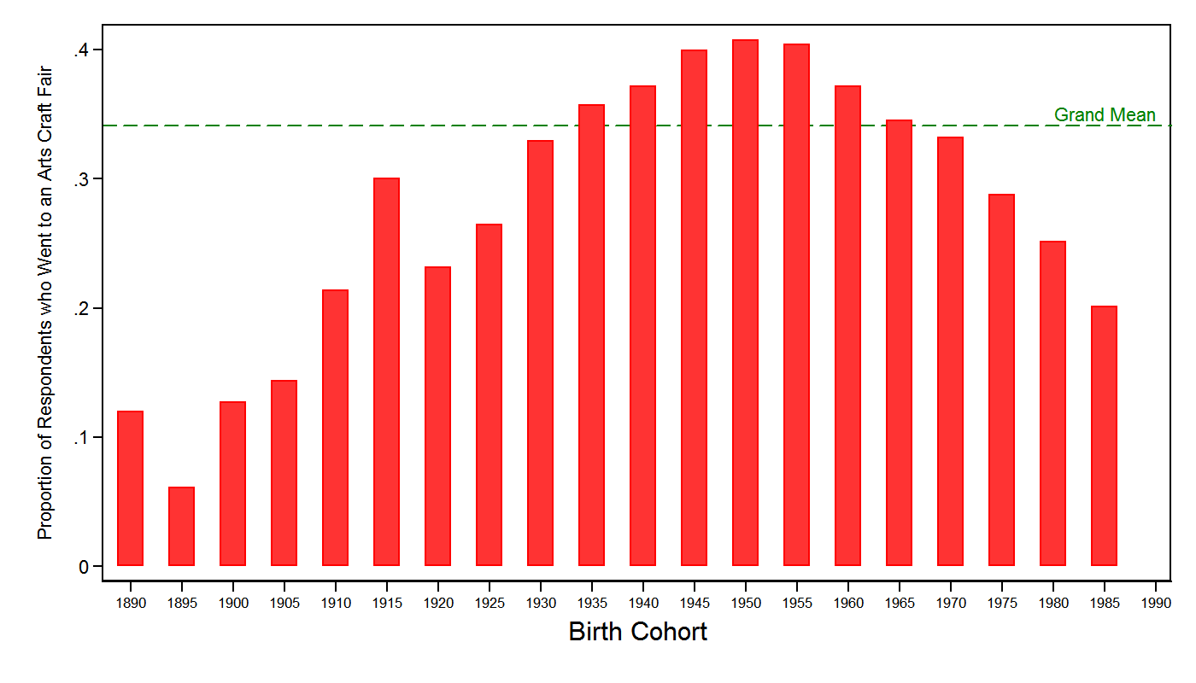

Now look at the "raw period" plot. Here, the main thing that we see is a negative period effect, with attendance dropping to nothing in 2008. But the period effect is also confounded by cohort and age. The observed naive period effect could be the result of differential mortality of people born between 1940s and 1950s and their replacement by useless young people or it could be a true period effect. We can't tell.

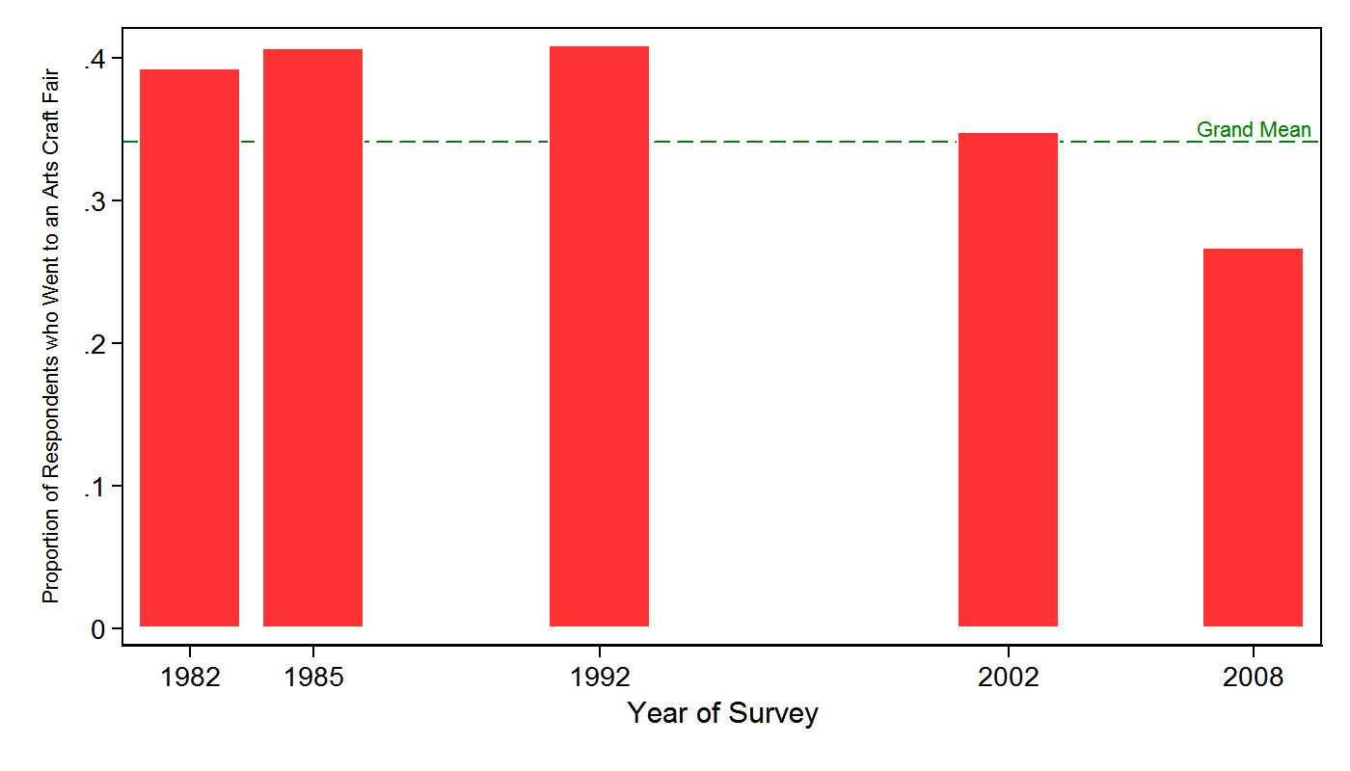
Now, we apply some statistical magic, and net out the effect of age, and estimate the net effect of both period and cohort adjusting for one another. First, look at the "net-cohort" graph. Bars below zero means that that cohort is less likely to attend controlling for age and year of survey, and bars above zero means that they are more likely to attend. Notice that there is curvilinear pattern, but is not the same as in the raw data. The true cohort effect is really located in the 1930-1950 generation. There is no cohort effect for those born in the 60s, while there is a (negative) cohort effect for people born in the 80s, similar to that who afflicts people born in the early 20th century.
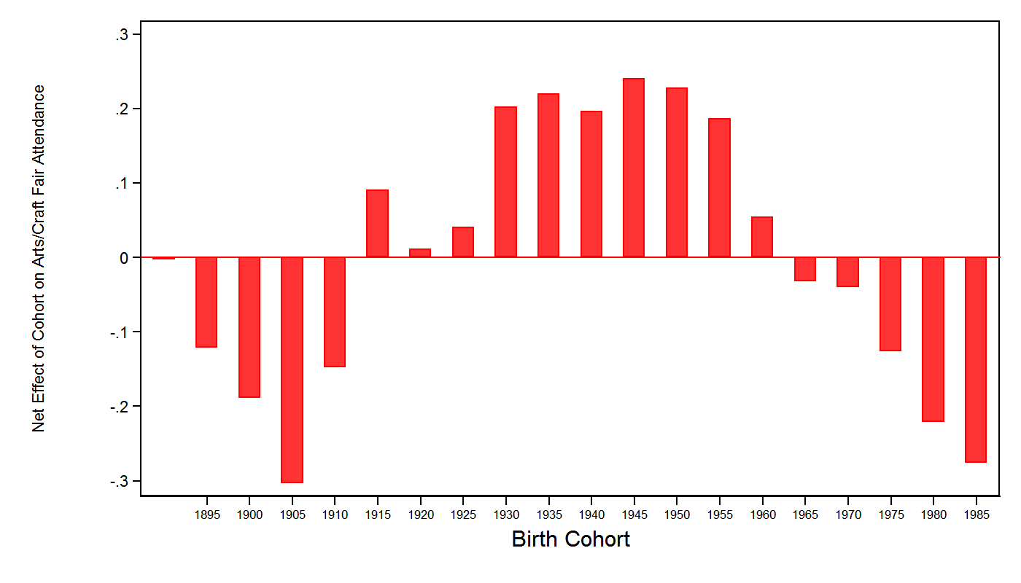
The net period chart just shows that the 2008 effect is real, and is not due to young people not going to arts/crafts fair (maybe an effect of the crisis?), this seems less interesting. People born in the 1930s come of age between 1945 and 1955 which I think fits the story that you tell in terms of the height of institutional entrepreneurship around the WPA. If that fits, we can tell a strong story not just outlining a production of culture argument, but also making a case for an effect on consumption which allows us to do the elusive macro-micro dance. If we can also tell story about the decline in recent cohorts even better!
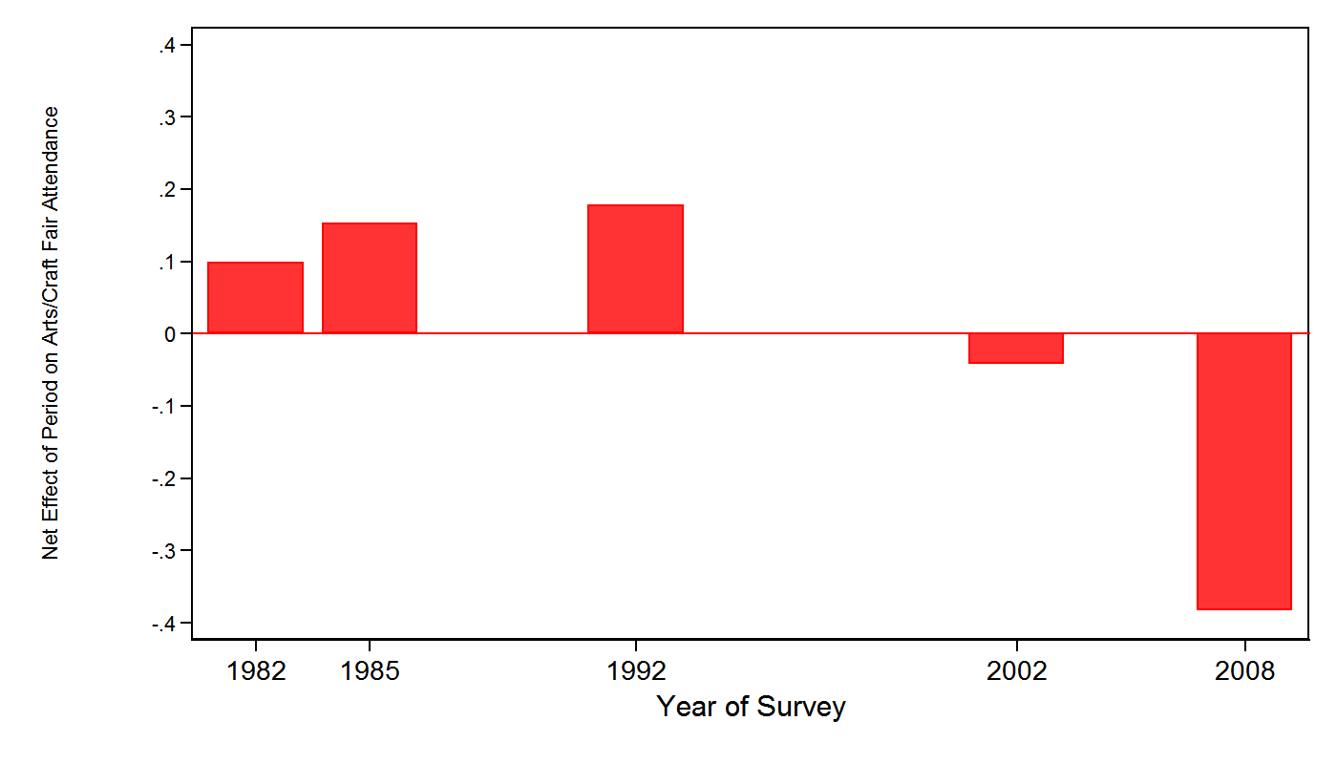

It is important to note that sociologists have begun to question the generalizability of Peterson and Kern’s (1996) finding to later waves of SPPA respondents. Rossman and Peterson (2013) discovered that by 2002, omnivorousness had receded to the same level as 1982, and remained low in the next (2008) survey wave. Their results suggest that omnivorousness might have simply been a fad and not a robust shift in taste. Alternatively, the pattern may be an artifact of survey administration, since the 1982 and 1992 surveys may have had more attentive respondents than those in 2002 and 2008. A 2012 survey was conducted but the NEA has withdrawn the data files from circulation, citing an error in how weights were assigned; they have just this week (10-20-14) become available to researchers.
Biddle wrote to Roosevelt in early 1933 recalling a sketching trip he had recently made through Mexico with muralist and painter Diego Rivera. He pressed his friend to envision hundreds of young, American painters producing (with government assistance) an artistic school as significant as the one growing among Mexican painters (N.A. 1936 “Art: Government Inspiration”).
Scholars (Reuss 1971) have pointed to the importance of the Communist Party’s adoption of folk music, especially protest songs, as domestic, proletarian music. The history of Party activities suggests an interest in indigenous, working-class music preceded the WPA initiatives, illuminating ideological precedents for Roosevelt’s programs.
It was not, however, a novel conceptualization of the American agenda. Ralph Waldo Emerson (1860: 84-6) had put the question to the American public generations earlier (nearly a century, in fact): he explained that “how to give all access to the masterpieces of art and nature, is the problem of civilization.”
It appears that the Theater Division was a kind of bête noir from the beginning, plagued by accidents and mistakes. Consider the gaffe reported in a March, 1936 issue of Time Magazine (N.A. 1936, “Theatre: Double-Jeopardy”): “FTP Vaudeville Production 4-A was booked to appear at Manhattan’s Stuyvesant High School, while Production 3-A was to be sent to amuse U.S. soldiers stationed on Governor’s Island. Through some stupid blunder, the soldiers, to their great disgust, were offered 4-A, a skit called School Days in which frisky scholars tossed apples at their teacher and blurted low-caliber puns. To Stuyvesant High School, on the other hand, went 3-A, a divertissement called Parisian nights. Intended for military consumption, this program included a scene between a bare-legged young woman, a master of ceremonies and an importunate young man. Sample dialog: M. of C.—Meet Lulu, 15 and never been kissed. He—It’s a cinch she don’t hang out in Battery Park. Give me a kiss. She—Give me a dollar first. He—Aw, you’re over 15.”
Although the study was focused on a particular symphony orchestra, Mary Ann Glynn (2002) has similarly found that exogenous shocks in combination with management practices can change the content of musical programs.
See Lamont 1992: 107 on cosmopolitanism and the definition is found in Beck 2002: 17. Peterson (2005: 260 n.7) also suggests the utility of the term. This comparison is indebted to Johnston and Baumann 2007: 167 n. 2.

